Software engineering for big data analaysis

CSA-1035

EXP NO: 9

9. Draw a Class diagram for Online Voting System using CASE tools. eVote is an election system that facilitates voters to record their secure and secret ballot electronically. It has a friendly user interface and enables voters to cast their votes in a few simple steps. We ensure the authenticity of the voters and the votes cast by them along with non-traceability of the casted vote elaborate the whole process of e-voting

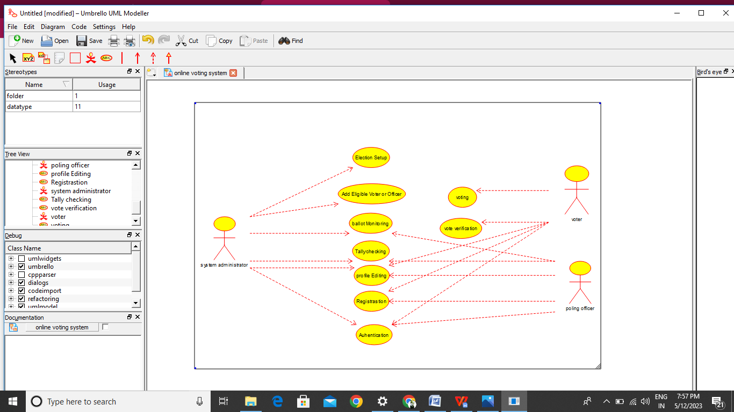

Result:-

Thus the use-case diagram from e online voting is drawn and verified successfully.